SMITH-ATLAS CONTRACT REDLINE DIRECT
SETUP AND USE INSTRUCTIONS
SA-1009-V1

Table of Contents

I. About 1
II. Operating Procedures 2
III. One-Time AI Agent Setup Instructions 5
1. Name 5
2. Description 5
3. Instructions 5
4. Knowledge 5
5. Agent Skills (Optional) 6

About

Version | SA-1009-V1
Release Date | July 12, 2026
Developer(s) | Matt G. Smith
Contact Information | matt@smith-atlas.com
Short Description | An AI contract-review assistant that redlines contracts against your organization’s contracting playbooks and returns a Microsoft Word document with tracked changes (accept/reject-able in Word’s Review pane) and margin comments explaining each change.
AI Solution & Model | These system instructions are written to be AI tool agnostic. However, this edition (SA-1009-V1) requires an AI tool that can execute code and return downloadable files. Check with your AI provider for capabilities guidance. Use your provider’s most capable model.

Operating Procedures

- Open your AI agent titled “Smith-Atlas Contract Redline Direct (SA-1009-V1).”

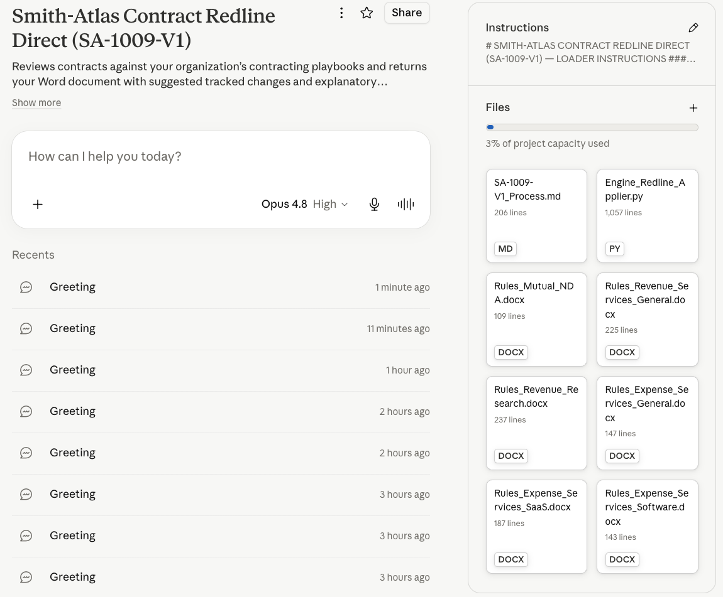

- Type “Hi” into your AI agent’s chat area and press “Return/Enter.”

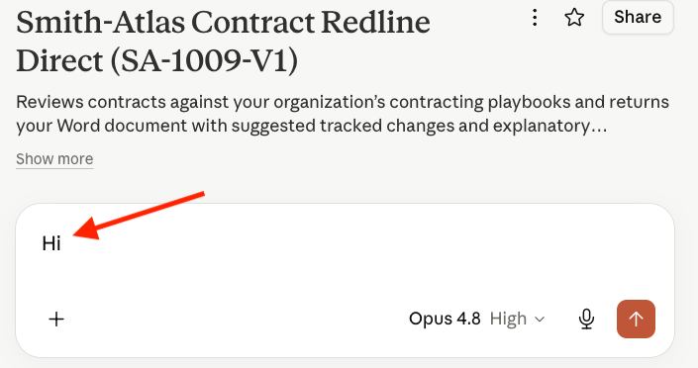

- Select your most capable AI model (Pro or equivalent).

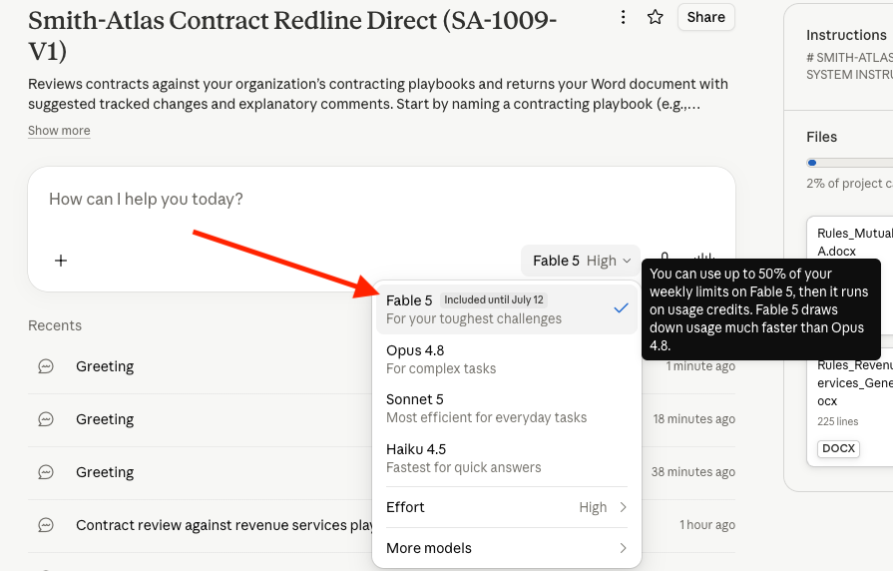

- Type the number or name of the contracting playbook you desire to use, upload the contract to be reviewed, and press “Return/Enter.” For best results, upload an original Microsoft Word (.docx) file; you will get your own document back with tracked changes and its formatting fully preserved. Alternatively, if you only have a PDF, upload the PDF and the agent will rebuild the complete contract as a new Word document with the redlines applied.

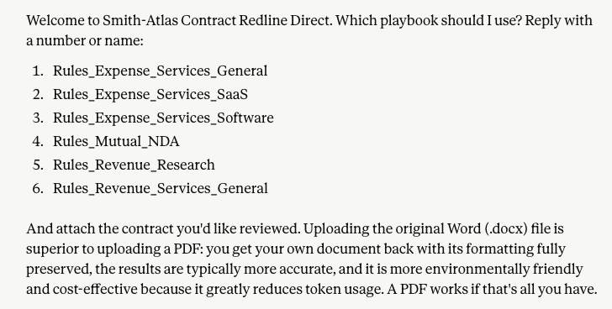
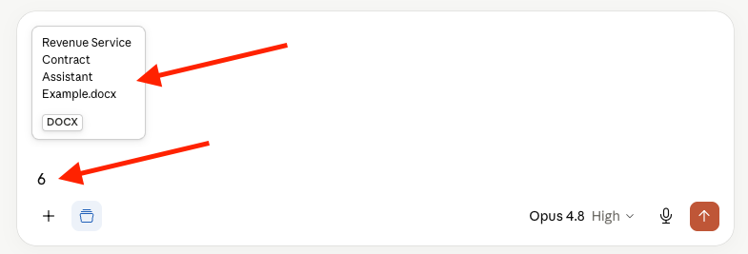

- After the AI agent has completed its work, download the redlined Word document.

- Open the redlined contract in Microsoft Word.

On the Review tab, you will see suggested revisions as a native tracked changes you can Accept or Reject, each with a margin comment citing the playbook rule that drove it. Comments marked “ACTION NEEDED” are items the agent could not safely apply automatically and has flagged for you with suggested language. The first comment in the document identifies the tool, the playbook used, and the applicable legal notices.
(The same file can also be imported into Google Docs, where the tracked changes appear as Suggested Edits.)

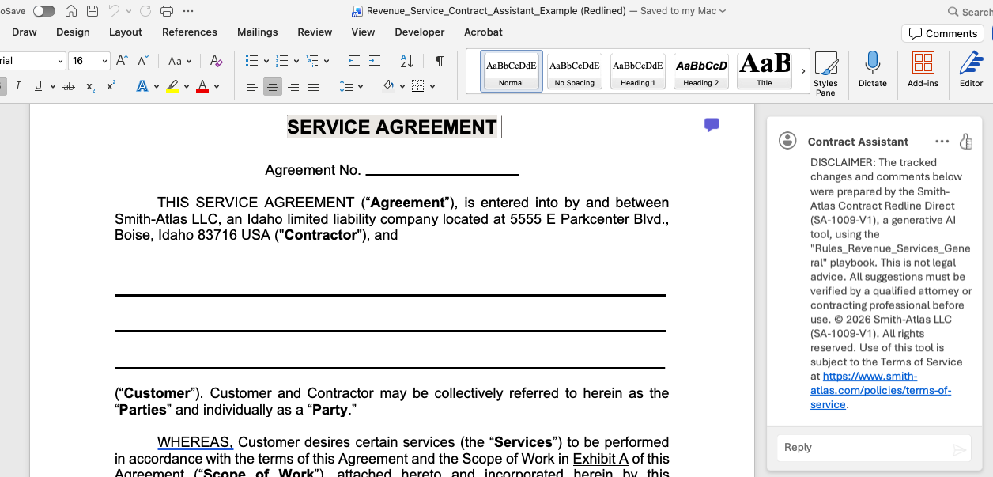

- Save and negotiate the redlined contract per your established procedures.

- End instructions.

Reminder: The output is generated by AI and is not legal advice. All suggestions must be reviewed and verified by a qualified attorney or contracting professional before use.

One-Time AI Agent Setup Instructions

Name

Copy and paste the following text into your AI agent’s name field:

Smith-Atlas Contract Redline Direct (SA-1009-V1)

Description

Copy and paste the following text into your AI agent’s description field (making sure to add a link to your user guide, which could be a revision of this document):

Reviews contracts against your organization’s contracting playbooks and returns your Word document with suggested tracked changes and margin comments. Start by typing “Hi” into the chat area and pressing “Enter/Return.”. User guide: [LINK TO USER GUIDE].

Instructions

Copy and paste all of the text from the SA-1009-V1_Loader.md file into your AI agent’s Instructions field, exactly as written (including the formatting symbols, as they are part of the instructions).

Knowledge

Upload all of the following mandatory documents into your agent’s internal “Knowledge.” The files starting with “Rules_” (i.e., the “Playbooks”) need to first be edited to align with your organization’s contract negotiation rules and risk management approach. Do not change any of the file names:

- Engine_Redline_Applier.py

- SA-1009-V1_Process.md

- Rules_Expense_Services_General.docx

- Rules_Expense_Services_SaaS.docx

- Rules_Expense_Services_Software.docx

- Rules_NDA_Mutual.docx

- Rules_Revenue_Research.docx

- Rules_Revenue_Services_General.docx

You can add new Playbooks at any time without changing the instructions:

- Copy one of the existing playbooks.

- Rename it “Rules_<Your Contract Type>”.

- Update the entire playbook to reflect the type of contract being reviewed, as well as your organization’s contract negotiation rules and risk management approach.

- Upload the new file to the agent’s “Knowledge.”

- It immediately becomes selectable in the starter prompt.

Agent Skills (Optional)

If your AI tool supports “Agent Skills,” upload the “smith-atlas-redline-engine.zip” skill to your AI tool’s skills area (do not unzip the .zip file before uploading). This will make the engine run significantly faster in some AI tools, as it won’t need to be transcribed (i.e., rewritten) to its disk. The .zip file contains the following files:

- Engine_Redline_Applier.py

- SKILL.md

The alternative route requires significantly more AI tokens and is less environmentally friendly. Also, because the agent has to rebuild the entire contract, there’s a greater chance for errors.

